Unit-1
8086 MICROPROCESSOR ARCHITECTURE & PROGRAMMING
Introduction To 8085
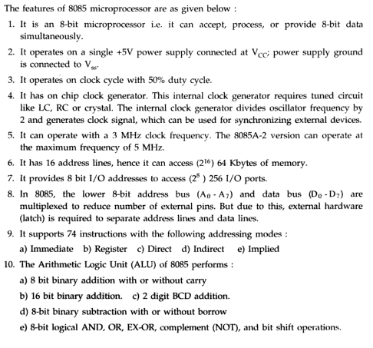
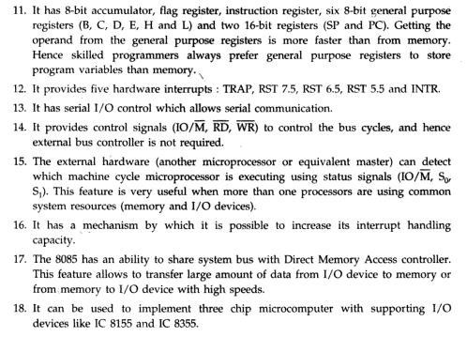

- ARCHITECTURE OF 8086 MICROPROCESSOR:
Features:
Intel released its first 16-bit microprocessor 8086 in 1978.The Intel 8086 is a 16-bit processor ,which is fabricated using HMOS technology and it has 40 pins ,packaged in DIP .

- The 8086 is a 16-bit microprocessor. The term 16-bit means that its arithmetic logic unit, internal registers and most of its instructions are designed to work with 16-bit binary words.
- The 8086 has a 16-bit data bus, so it can read data from or write data to memory and ports either 16 bits or 8 bits at a time. The 8088, however has an 8-bit data bus, so it can only read data from or write data to memory and ports 8 bits at a time.
- The 8086 has a 20-bit address bus, so it can directly access 2²⁰ or 10, 48,576 (1MB) memory locations. Each of the 10, 48,576 (1MB) memory locations is byte wide. Therefore, a 16-bit word is stored in two consecutive memory locations. The 8088 also has a 20-bit address bus, so it can also address 2²⁰ memory locations.
- The 8086 can generate 16-bit I/O address, hence it can access 2¹⁶=65536 I/O ports.
- The 8086 provides fourteen 16-bit registers.
- The 8086 has multiplexed address and data bus which reduces the number of pins needed, but does slow down the transfer of data.
- The 8086 requires clock with a 33% duty cycle to provide optimized internal timing.
- The 8086 microprocessor available in three clock rates: 5 MHz (8086), 8 MHz (8086-2) and 10 MHz (8085-1).
- The Intel 8086 is designed to operate in two modes: minimum mode and maximum mode.
- Minimum mode: When only one 8086 CPU is to be used in a microcomputer system, the 8086 is used in the minimum mode of operation.
- Maximum mode: More than one processor (multiprocessor) is used in the system, the 8086 is used in the maximum mode of operation.
- An interesting feature of the 8086 is that it fetches up to 6 instruction bytes from memory and queue stores them in order to speed up instruction execution.
- It requires +5V single power supply.

Architecture:
The internal architecture of 8086 microprocessor is shown in figure below.As below by the block diagram in figure, the 8086 processor is divided into two independent functional parts, the Bus Interfacing Unit (BIU), and the Execution Unit (EU). Dividing the work between these two units speeds up processing.

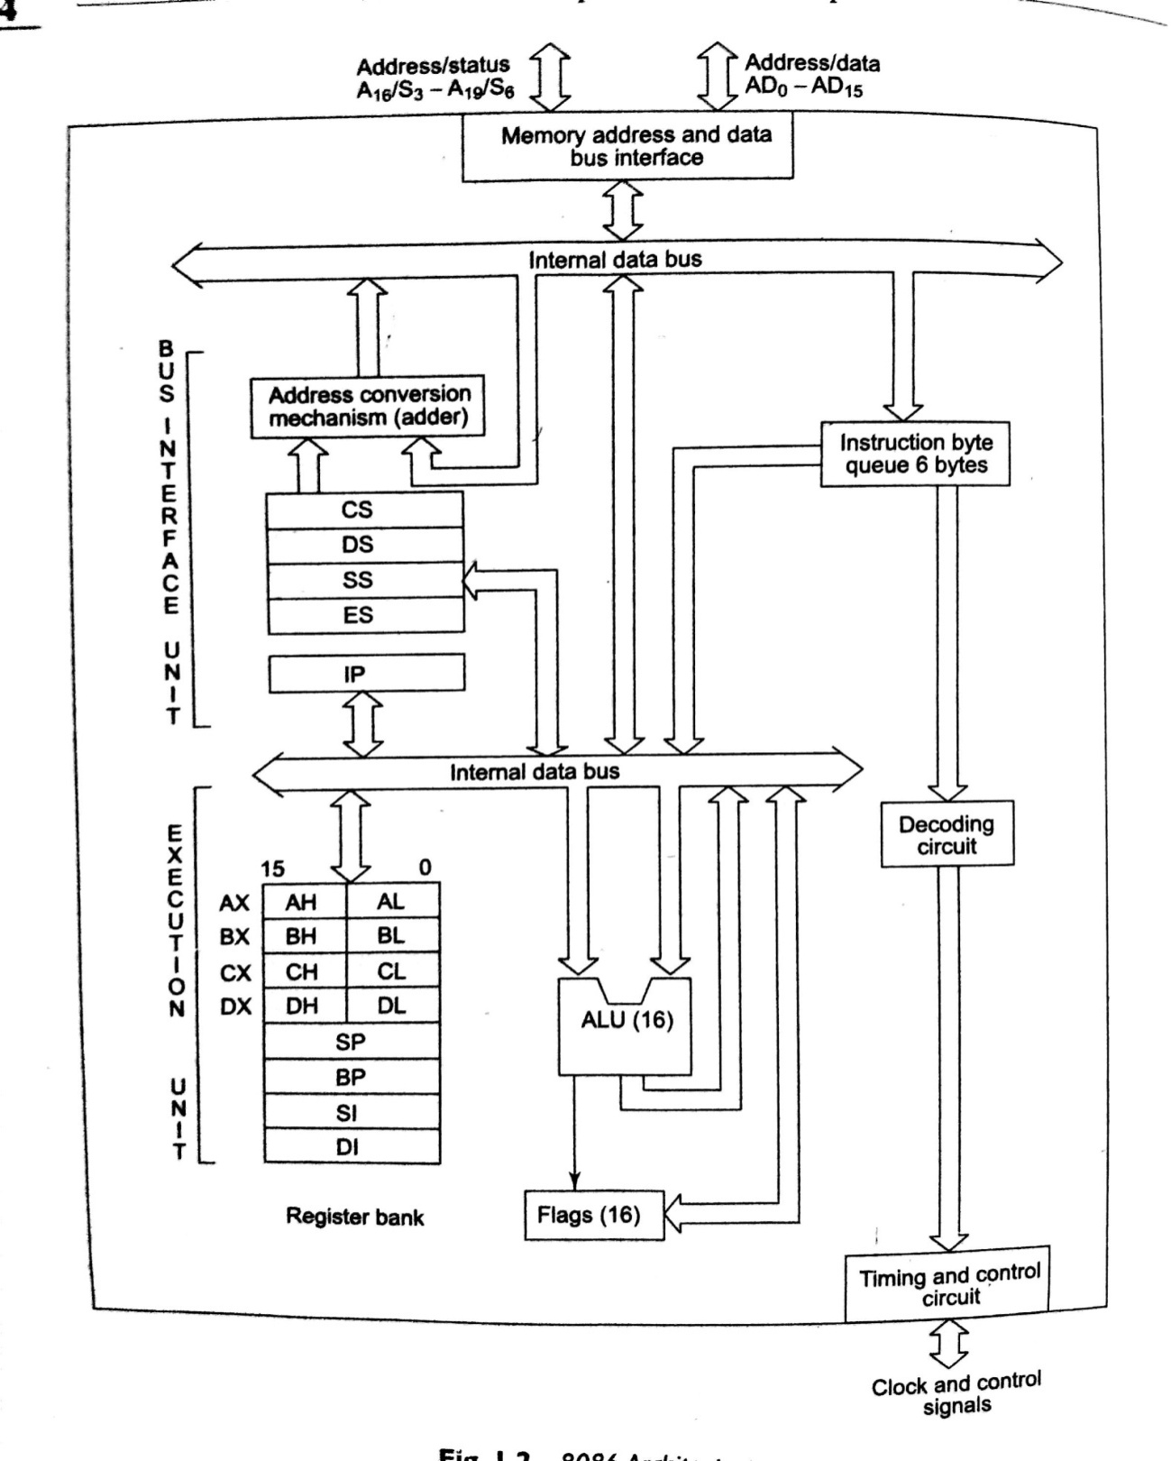
BLOCK DIAGRAM OF 8086

The BIU sends out addresses, fetches instructions from memory, reads data from ports and memory, and writes data to ports and memory. In other words, the BIU handles all transfers of data and addresses on the buses for the execution.
The EU of the 8086 tells the BIU where to fetch instructions or data from, decodes instructions, and executes instructions.
1. Bus Interfacing Unit: The bus interfacing unit in 8086 provides the interface to the outside world. This unit is responsible for performing all external bus operations like fetches instructions from memory, reads data from ports and memory, and writes data to ports and memory.
The queue: To speed up program execution, the BIU fetches six instruction bytes ahead of time from the memory. The BIU stores these perfected bytes in a first-in-first-out register set called a queue. When the EU is ready for its next instruction, it simply reads the instruction byte for the instruction from the queue in the BIU. This is much faster than sending out an address to the system memory and waiting for memory to send back the next instruction byte or bytes. The process is analogous to the way a bricklayer’s assistant fetches bricks ahead of time and keeps a queue of bricks lined up so that the brick layer can just reach out and grab a brick when necessary. Except in the cases of JMP and CALL instructions, where the queue must be damped and then reloaded starting from a new address. So, the queue operates on the principle first in first out (FIFO).So that the execution unit gets the instructions for execution in the order they are fetched. This prefetch-and-queue scheme greatly speeds up processing. Fetches the next instruction while the current instruction executes is called pipelining.

2. Execution Unit: The EU of 8086 tells the BIU from where to fetch instructions or data, decodes instructions and executes instructions. As shown in figure, the EU contains: control unit, decoder, ALU and a registers.
Control unit: This directs internal operations.
Decoder: A decoder in the EU translates instructions fetched from memory into a series of actions which the EU carries out.
ALU: The EU has a 16-bit arithmetic logic unit which can add, subtract, AND, OR, XOR, increment, decrement, complement and shift binary numbers.

REGISTER ORGANIZATION:-

General purpose registers:
The EU has four 16-bit general purpose registers labeled as AX, BX, CX, and DX. These registers can be used temporary storage of 16 -bit data. The AX register is also called as Accumulator.
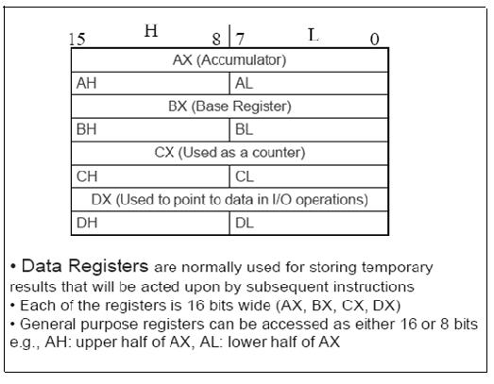
AX (Accumulator): The register AX is used to store the result produced by the ALU. So, it is called as Accumulator.
BX (Base Register): The register BX is used as offset storage for generating physical addresses in case of certain addressing modes.
CX (Counter Register): The register CX is used as default counter in case of string and loop instructions.
DX (Data Register): The register DX is used as destination (store the result data) in case of multiplication and division instructions.
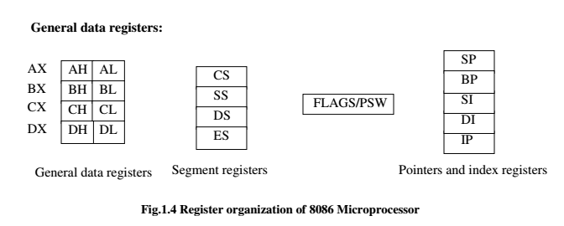
Segment registers:-

The segment registers in BIU are used to define the starting address of logical segment. It holds the upper 16-bits of starting address of logical segment.
There are 4- segment registers: 1. Code Segment register (CS)
2. Data Segment register (DS)
3. Extra Segment register(ES)
4. Stack Segment register(SS)
Code Segment register:
The CS register is used to hold the upper 16-bits of starting address of the Code segment. The BIU inserts ZERO’s for lower 4-bits of 20-bit starting address.
For example, if CS=2000H then the Code segment starts at 20,000H.

Data Segment register:
The DS register is used to hold the upper 16-bits of starting address of the Data segment. The BIU inserts ZERO’s for lower 4-bits of 20-bit starting address.
The data segment is a section of memory that contains data variables and constants of the program. Data are accessed from Data segment by an Offset address. The SI, DI, BX, BP registers are used to store the Offset address for data segment.

Extra Segment register:
The ES register is used to hold the upper 16-bits of starting address of the Extra segment. The Extra segment is an additional data segment used in String operations. The DI, SI, BX, BP registers are used to store the Offset address for extra segment.

Stack Segment register:
The SS register is used to hold the upper 16-bits of starting address of the Stack segment. The Stack segment defines the area of memory used for stack.
The Stack Pointer (SP) register holds the address of Stack top.

Instruction Pointer (IP):

The IP register holds the Offset address of the next instruction to be fetched from Code segment.
The Offset address/ Effective address is the distance of Operand from the Starting address of the Segment.

Flag registers: A flag is a flip-flop which indicates some condition produced by the execution of an instruction or controls certain operations of EU. The flag register contains nine active flags.
8086 FLAG REGISTER AND FUNCTION OF 8086 FLAGS:
A flag is flip-flop that indicates some condition produced by the execution of an instruction or controls certain operations of the EU. A 16-bit flag register in the EU contains nine active flags. The figure shows the location of the nine flags in the flag register. Six of the nine flags are used to indicate some condition produced by an instruction. The six conditional flags in this group are the carry flag (CF), the parity flag (PF), the auxiliary carry flag (AF), the zero flag (ZF), the sign flag (SF), and the overflow flag (OF). The names of these flags should give you hints as to what conditions affect them.Cetain 8086 instructions check these flags to determine which of two alternative actions should be done in executing the instruction. The six conditional flags are set or reset by the EU on the basis of the results of some arithmetic or logic operation.
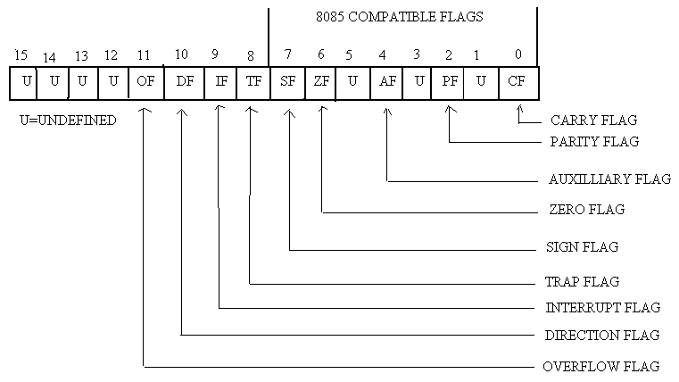

Fig. 8086 flag register format
The description of each flag bit is as follows:
Carry flag: This flag is set when there is a carry out of MSB in case of addition or a borrow in case of subtraction. For example, when two numbers are added, a carry may be generated out of the MSB position. The carry flag, in this case will be set to ‘1 ‘. In case no carry is generated it will be ‘0 ‘.
Parity flag: This flag is set to 1 if the lower byte of the result contains even number of 1s, other wise it is zero.
Auxiliary flag: This is set if there is a carry from the lowest nibble during addition or borrow for the lowest nibble during subtraction.
Zero flag: This flag is set if the result of operation in ALU is zero and the flag resets if the result is nonzero.
Sign flag: After execution of arithmetic or logical operations, if the MSB of the result is 1, the sign flag is set. Sign flag equals the MSB of the result. Sign bit 1 indicates the result is negative.
Overflow flag: This flag is set if result is out of range. For addition this flag is set when there is a carry into the MSB and no carry out of the MSB or vice-versa. For subtraction, it is set when the MSB needs a borrow and there is no borrow from the MSB, or vice-versa.
The three remaining flags in the flag register are used to control certain operations of the processor. These flags are different from the six conditional flags described above. The control flags are the trap flag (TF), the interrupt flag (IF), the direction flag (DF). The descriptions of these flags are explained as follows:

Trap flag: If this flag is set, the processor enters the single step execution mode. In other words, a trap interrupt is generated after execution of each instruction. The processor executes the current instruction and the control is transferred to the trap interrupt service routine.
Single stepping: One way to debug a program is to run the program one instruction at a time and see the contents of used registers and memory variables after execution of every instruction. This process is called single stepping through a program.
Interrupt flag: If this flag is set, the maskable interrupts are recognized by the processor ,otherwise they are ignored.
Direction flag: This is used by string manipulation instructions. If this flag bit is ‘0’, the string is processed beginning from the lowest address to the highest address, i.e.autoincrementing mode. Otherwise, the string is processed from the highest address towards the lowest address, i.e.autodecrementing mode.
Example:
1. Give the contents of flag register after execution of following addition.

0110 0101 1101 0001
0010 0011 0101 1001
+ --------------------------
1000 1001 0010 1010
Solution: SF=1, ZF=0, PF=1, CF=0, AF=0, OF=1

2. Give the contents of flag register after execution of following subtraction.

0110 0111 0010 1001
0011 0101 0100 1010
---------------------------
0011 0001 1101 1111
Solution: SF=0, ZF=0, PF=1, CF=0, AF=1, OF=0

Pointer and Index registers:
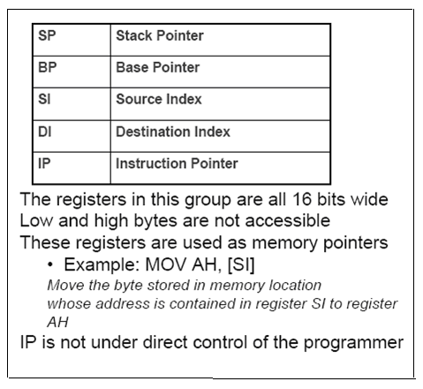
- The Index Registers are used to hold the Offset address of data stored in Data and Extra segments.
- Index registers are used in string operations to hold the Offset address of source and
- destination strings.
- The SI register holds the offset address of source string in Data Segment.
The DI register holds the offset address of destination string in Extra Segment.
Address of Source string à DS: [SI]
Address of destination string à ES:[DI]
The directional flag(DF) selects the increment/ decrement mode for SI and DI registers during
String instructions manipulation.

DF = 0 selects increment mode & DF = 1 selects decrements mode.

Pointers :

- The Pointers are are used to hold the Offset address relative to data and stack segments.
- The base pointer (BP) is used to access data in stack segment
- The stack pointer is used to hold the address of stack top.
Memory Segmentation:

The 8086 uses memory segmentation. In this scheme, the complete 1 M bytes of physical memory is divided into number of logical segments of size 64 K bytes. Thus a location within a segment can be addressed by 16-bit address.
The 64 K bytes logical segment can be located anywhere in 1 M bytes of memory, but the segment will always start at an address with ZERO’s in lowest 4-bits.
The segment registers in BIU are used to define the starting address of logical segment. It holds the upper 16-bits of starting address of logical segment.

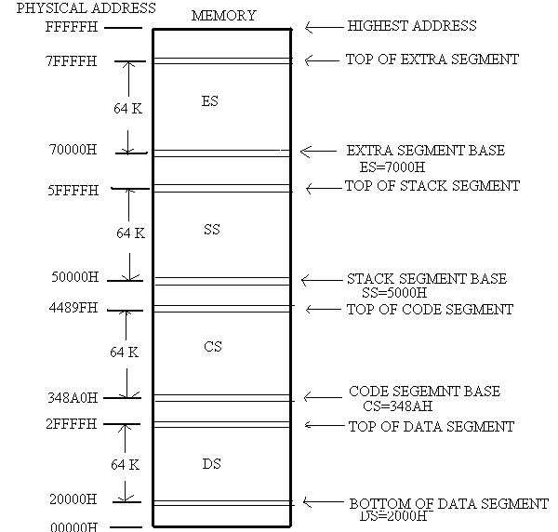
MEMORY SEGMENTATION OF 8086

The addresses of the segment may be assigned as 0000H to F000H respectively.
An offset address is used to address a specific memory location within the segment.
The offset address values are from 0000H to FFFF H so that the physical addresses range from 00000H to FFFFF H.

Rules for memory segmentation:
- The four segments can overlap for small programs. In a minimum system all the four segments can start at the address 00000H.
- The segment can start at any memory address which is divisible by 16.
Advantages:
- It allows the memory addressing capacity to be 1 MB even though the address associated with individual instruction is only 16-bit.
- It allows instruction code, data, stack, and portion of program to be more than 64 KB long by using more than one code, data, stack and extra segment.
- It provides use of separate memory areas for program, data and stack.

Physical Memory Organization
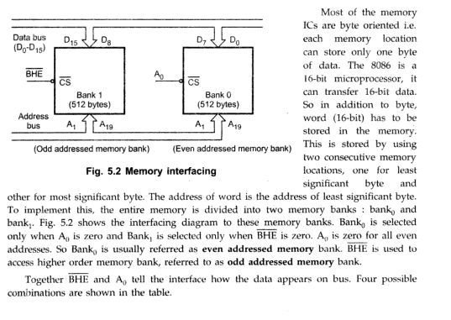
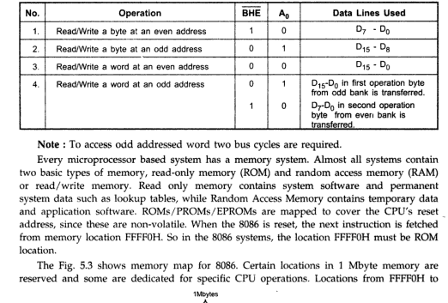

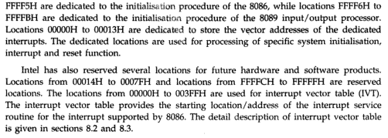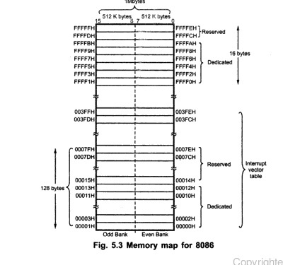
I/O addressing Capability:
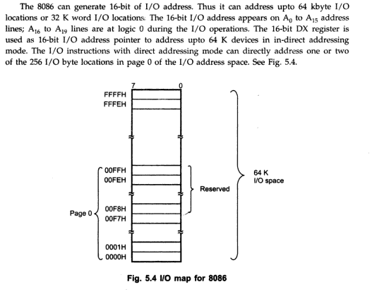

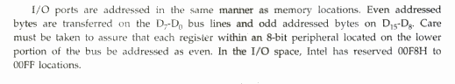

Addressing Modes of 8086:
1. Immediate addressing mode : In this addressing mode, immediate data is a part of instruction, and appears in the form of successive byte or bytes.
ex. MOV AX, 005 OH
Here 005OH is the immediate data and it is moved to register AX. The immediate data may be 8-bit or 16-bit in size.
2. Direct addressing mode : In the direct addressing mode, a 16 bit address (offset) is directly specified in the instruction as a part of it.
ex. MOV AX [1 0 0 0 H]
Here data resides in a memory location in the data segment, whose effective address is 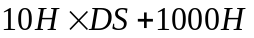
3. Register addressing mode : In register addressing mode, the data is stored in a register and it is referred using the particular register. All the registers except IP may be used in this mode.
ex. MOV AX,BX
4. Register Indirect addressing mode: In this addressing mode, the address of the memory location which contains data or operand is determined in an indirect way using offset registers. The offset address of data is in either BX or SI or DI register. The default segment register is either DS or ES.
e.g. MOV AX, 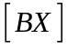
The data is present in a memory location in DS whose offset is in BX. The effective address is 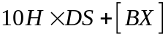
5. Indexed addressing mode: In this addressing mode offset of the operand is stored in one of the index register. DS and ES are the default segments for index registers SI and DI respectively
e.g. MOV AX, 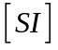
The effective address of the data is 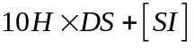
6. Register Relative addressing mode : In this addressing mode the data is available at an effective address formed by adding an 8-bit or 16-bit displacement with the content of any one of the registers BX, BP, SI and DI in the default either DS or ES segment.
e.g. MOV AX, 50H
The effective address of the data is 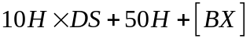
7. Based Indexed addressing mode: In this addressing mode the effective address of the data is formed by adding the content of a base register (any one of BX or BP) to the content of an index register (any one of SI or DI). The default segment register may be ES or DS.
e.g MOV ,
The effective address is 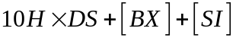
8. Relative Based Indexed addressing mode : The effective address is formed by adding an 8-bit or 16-bit displacement with the sum of contents of any one of the base register (BX or BP) and any one of the index registers in a default segment.
e.g. MOV AX, 50H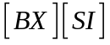
Here 50H is an immediate displacement. The effective address is 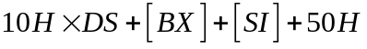.
9. Intrasegment Direct addressing Mode: In this mode, the address to which the control is to be transferred lies in the segment in which the control transfer instruction lies and appears directly in the instruction as an immediate displacement value. The displacement is computed relative to the content of the instruction pointer IP.
10. Intrasegment Indirect addressing Mode: This mode is similar to intrasegment direct mode except the displacement to which control is to be transferred is passed to the instruction indirectly. Here the branch address is found as the content of a register or a memory location.

11. Intersegment Direct addressing Mode: In this mode, the address to which the control is to be transferred is in a different segment. This addressing mode provides a means of branching from one code segment to another code segment. Here, the CS and IP of the destination address are specified directly in the instruction.

12. Intersegment Indirect addressing Mode: This mode is similar to intersegment direct mode except the address to which the control is to be transferred is passed to the instruction indirectly. This information is kept in a memory block of 4 bytes: IP(LSB), IP(MSB), LS(LSR) and CS(MSB) sequentially. The starting address of the memory block may be referred using any of the addressing modes, except immediate mode.

Instruction set of 8086:

The 8086 instructions are categorized into eight different groups.

a) Data Transfer Instruction: This type of instructions are used to transfer data from source operand to destination operand. All the store, load, move, exchange, input and output operations belong to this category.

b) Arithmatic and Logical Instructions: All the instructions performing arithmetic , logical, increment, decrement, compare and scan instructions belong to this category.

c) Branch Instructions: These instructions transfer control of execution to the specified address. All the call, jump, interrupt and return instructions belong to this category.

d) Loop Instructions: The LOP, LOOPNZ and LOOPZ instructions belong to this category. These are useful to implement different loop structures.

e) machine control Instructions: These instructions control the machine status. NOP, HLT, WAIT and LOCK instructions belongs to this category.

f) Flag Manipulation Instructions: All instructions which directly affect the flag register belong to this category. The instructions CLD, STD, CLI, STI etc. belong to this category.

g) Shift and Rotate Instructions: These instructions involve the bitwise shifting or rotation in either direction with or without a count in CX.

h) String Instructions: These instruction involve string manipulation operations like load, love, scan. Compare, store etc. These instructions are only to be operated upon the string.

Data Transfer operation:

MOV : move PUSH: Push to stack
POP: pop from stack XCHG: Exchange
IN: Input from the port OUT: Output to the port
XLAT: Translate LEA: Load effective address
LDS/LES: Load pointer to DS/ES
LAHF: Load AH from lower byte of Flag register
SAHF: Store AH to lower byte of Flag register
PUSHF: push Flags to stack
POPF: pop Flags from stack

Arithmatic operations
ADD: add ADC: Add with carry
INC: Increment DEC: Decrement
SUB: Subtract SBB: Subtract with Borrow
CMP: compare

AAA: ASCll Adjust After Addition
AAS: ASCll Adjust After Subtraction
AAM: ASCll Adjust for multiplication
AAD: ASCll Adjust for division
DAA: Decimal Adjust Accumulator
DAS: Decimal Adjust After Subtraction
NEG: Negative
MUL: Unsigned multiplication Byte or word.
IMUL : Signed multiplication
CBW: Convert signed Byte to Word
CWD: Convert signed word to double word
DIV: Unsigned Division
IDIV: Signed Division

Logical Instructions:

AND: Logical OR: Logiacl OR
NOT: Logical Invert XOR: Logical Exclusive OR
TEST: Logical compare Instruction
SHL/SAL: Shift logical/Arithmatic left
SHR: Shift logical Right
SAR: Shift Arithmatic Right
ROR: Rotate Right without carry
ROL: Rotate Left without carry
RCR: Rotate Right through carry
RCL: Rotate Left through carry
String Manipulation Instructions
PEP : Repeat Instruction prefix
MOVSB/MOVSW: Move string Byte or string word.
CMPS: Compare sting Byte or String word.
SCAS: Scan string Byte or string word
LODS: Load string Byte or String word
STOS: Store String Byte or String word

Control transfer or Branching Instructions:
-Unconditional Branch Instructions.
CALL: Unconditional Call
RET: Return from the procedure
INT N: Interrupt type N
INTO: Interrupt on overflow
JMP: Unconditional Jump
JRET: Return from ISR
LOOP: Loop unconditionally

-Conditional Branch Instruction:

JZ Label : Transfer control to ‘Label’ if 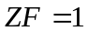
JZ Label : Transfer control to ‘Label’ if
JNZ Label : Transfer control to ‘Label’ if 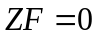
JS Label : Transfer control to ‘Label’ if 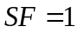
JNS Label : Transfer control to ‘Label’ if 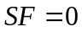
JO Label : Transfer control to ‘Label’ if 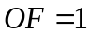
JNO Label : Transfer control to ‘Label’ if 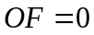
JP Label : Transfer control to ‘Label’ if 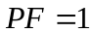
JNP Label : Transfer control to ‘Label’ if 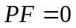
JB Label : Transfer control to ‘Label’ if 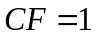
JNB Label : Transfer control to ‘Label’ if 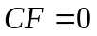
JBE Label : Transfer control to ‘Label’ if or
JNBE Label : Transfer control to ‘Label’ if or
JL Label : Transfer control to ‘Label’ if or
JNL Label : Transfer control to ‘Label’ if or
JLE Label : Transfer control to ‘Label’ if or neither SF nor OF is 1
JNLE Label : Transfer control to ‘Label’ if or at least any one of SF and OF is 1
LOOPZ label : Loop through a sequence of instructions from ‘Label’ while and 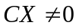
LOOPNZ label : Loop through a sequence of instructions from ‘Label’ while and .

Flag manipulator and Processor control instructions:

CLC – Clear carry flag
CMC- Complement carry flag
STC- Set carry flag
CLD- Clear direction flag
STD- Set direction flag
CLI- Clear interrupt flag
STI- Set Interrupt flag
WAIT- wait for test input pin to go low
HLT- Halt the processor
NOP- No operation
ESC- Escape to external device like NDP (numeric co-processor)
LOCK- Bus lock instruction prefix.

Assembler directives and operators:
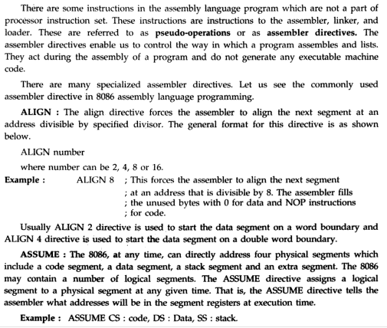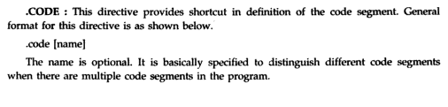
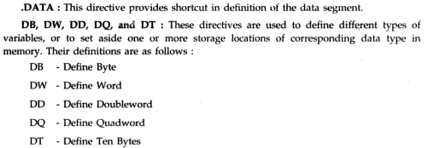

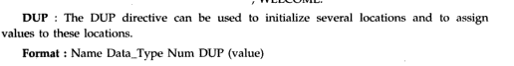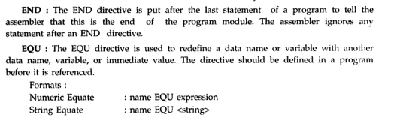
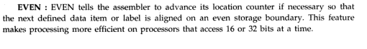
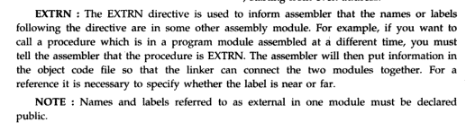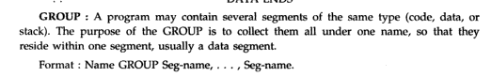
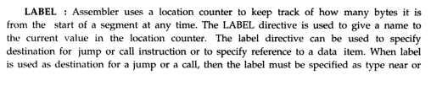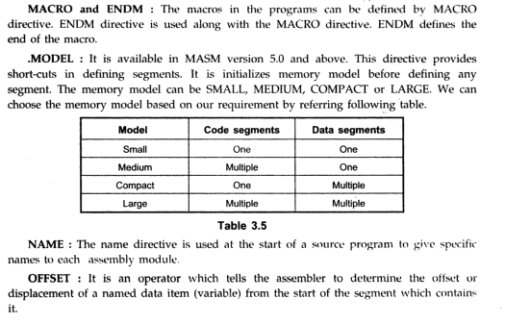
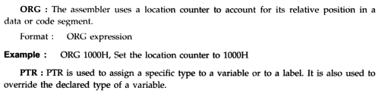
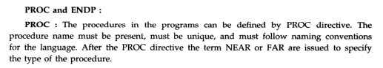
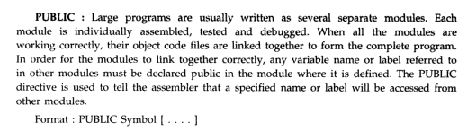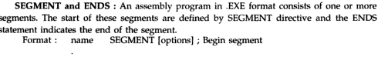
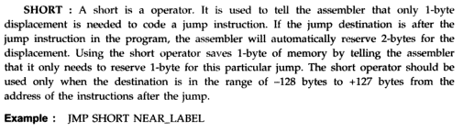
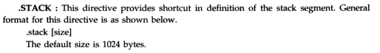
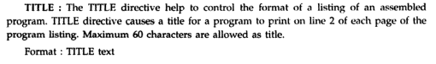
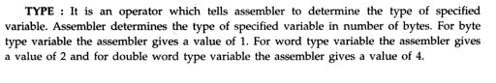

Assembly Language programming of 8086:

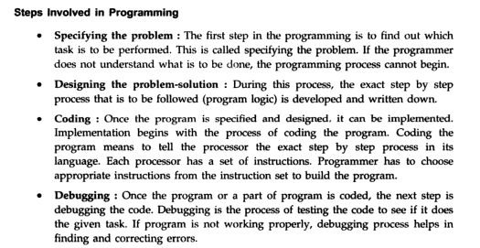
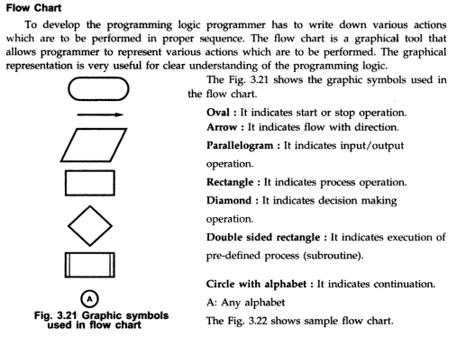

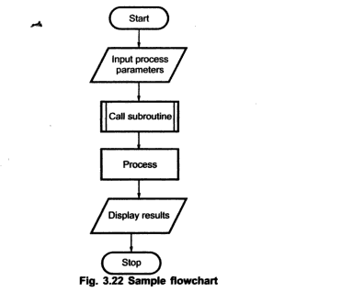

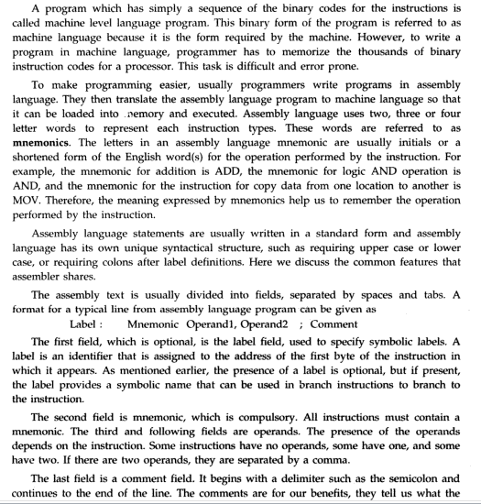
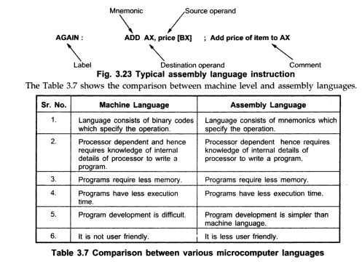

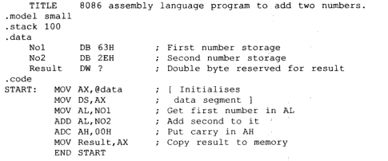
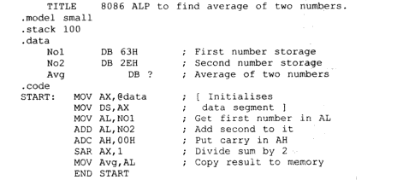
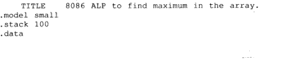
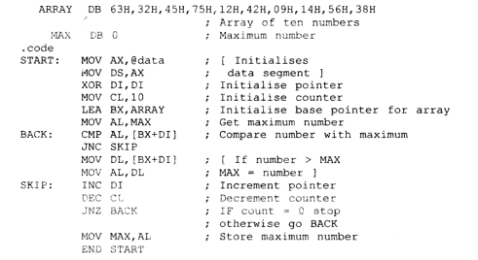

Introduction to stack, stack structure of 8086/8088:
